DON’T PANIC!!!
Work in progress: Things may read as disjointed….yes, I am presently bring together various thoughts and it will NOT read cleanly at all yet…

Developing Standard Approaches for Curating Small Molecule Pharmaceuticals
Antony J. Williams¹, David Sharpe¹, Andrew Fant², Ricard *****, Jordi Mestres³, Eugene Muratov², Denis Fourches², Valery Tkachenko¹, Alex Tropsha² and Sorel Muresan⁴
¹ Royal Society of Chemistry, 904 Tamaras Circle, Wake Forest, NC-27587, USA.
² Laboratory for Molecular Modeling, Eshelman School of Pharmacy, University of North Carolina, Chapel Hill, NC, USA.
³ Chemogenomics Laboratory, Research Programme on Biomedical Informatics, IMIM—Hospital del Mar Research Institute and Universitat Pompeu Fabra, Parc de Recerca Biomèdica, Doctor Aiguader 88, 08003 Barcelona, Catalonia, Spain.
⁴ AstraZeneca R&D Mölndal, S-431 83 Mölndal, Sweden.

Corresponding Author: Antony Williams, 904 Tamaras Circle, Wake Forest, NC27587 Email: williamsa@rsc.org Tel 919-201-1516.

Abstract
The Internet has been widely lauded as a great equalizer of information access. However, the absence of any central authority on content places the burden on the end-user to verify the quality of the information accessed. We have examined the accuracy of the chemical structures of ca. 200 major pharmaceutical products that can be found on the internet. We have demonstrated that while erroneous structures are commonplace, it is possible to determine the correct structures by utilizing a carefully defined structure validation workflow. We highlight some of the limitations of existing software platforms hosting public domain data, some of the challenges which can arise when moving data through various software tools, and limitations of existing formats for structure handling. In addition, we and others have shown that the use of un-curated structures affects the accuracy of cheminformatics investigations such as QSAR modeling. We posit that chemical datasets must be carefully curated prior to any cheminformatics investigations and furthermore that models built from carefully curated datasets can be used to correct erroneously reported biological data. We summarize best practices developed in our relative groups for data curation.

Data Quality
The progress of science can commonly depend on accessing data from previous experiments. Historically some of these data were contained within scientific publications or shared between laboratories using electronic exchange but nowadays there is an increasing abundance of data available in online databases and systems. A number of reports regarding available online resources are available [1-7] with a general review of the types of resources available presented by Williams [8]. An annual update of databases available is presented in the NAR reviews [XX] . While the internet offers access to rich sources of chemistry data for the purpose of data-mining, modeling and integration to expand data accessibility and aid discovery there certainly are risks. With this improvement in access to data comes the responsibility to ensure that data are as high a quality as possible to ensure that time is not wasted in erroneous searches, that models are underpinned by accurate data and that the improved discoverability of online resources is not marred by the delivery of incorrect data.
The impact of the correctness of molecular structures on computational models has been discussed previously (list). For chemistry databases there are, as yet, no agreed upon standards and no freely available gold standard structure database which we can yet rely on. The delivery of online databases has appeared to focus more on the development of the cheminformatics architecture rather than the delivery of a high quality resource of data. As yet there are no definitive guides for how to assemble and integrate disparate data sources and individual groups appear to follow custom unproven and undocumented approaches in assembling data. In the chemistry domain there is a need for the suppliers of chemistry-based community resources to work together and develop best practices to reduce the amount of repetition and lessen the impact of poor data assembly and these efforts are, fortunately, underway (ChEMBL paper). A curated online database of validated chemical name-structure relationships would provide a valuable contribution to a semantic web for chemistry, for chemistry text-mining, for integration to online resources and to allow for efficient disambiguation of chemical names. ChemSpider (vide infra) is providing just such a platform for the Open PHACTS semantic platform for the life sciences (XX).
A recent paper described in detail the effort that went into gathering “correct structures” to build a highly curated database of drug-related structures (NPC). However, our examination of the quality of the data in the “NPC browser” discussed how much more consideration and care is required when releasing chemistry related data into the public domain as even this “highly curated” database was shown to contain a high level of contamination and incorrect data.
A study has shown that scientists commonly “trust” online chemistry databases. An online survey (XX) requesting community feedback regarding the trust granted to online databases containing chemistry related information. It is suggested that no database should always be trusted but that does not represent the present situation (XX). In way too many cases explicit trust is granted to public domain resources without any evidence of data quality. A wiki environment listing online scientific databases and contributions and commentary from the community was recently introduced and might aid in providing a ranking of quality.
Data proliferation between databases
Online chemistry content dramatically overlaps with only a small number of key resources adding data of significant value to the internet. PubChem (XX) is a valuable resource in terms of hosting bioassay data associated with hundreds of thousands of chemicals. However, since the data are available for download and reuse many other resources have used the content thereby proliferating the original quality of PubChem, a known concern (XX). There are numerous examples of data from PubChem being sourced and redeposited back into the database. NextBio [XX] sourced the majority of its content from PubChem and utilize it as part of their integrated content system on platforms such as Elsevier. NextBio also deposited their content back to PubChem. The Chemical Translation Service [X] has clearly sourced the majority of their data from PubChem as the majority of erroneous name-structure synonyms have been migrated to the system. The same is true for many other databases and provenance is commonly lost. Since data proliferates between various online resources there is a growing problem as new databases appear.
The ambiguities of name-structure relationships
Chemicals can be associated with multiple forms of chemical identifiers. These include systematic names (IUPAC or CAS), trivial names, trade names, various other synonyms and various registry numbers. In addition parts of the community now use InChIs and InChIKeys as explicit chemical identifiers. Other than systematic names generated directly from the chemical structure, preferably generated by perfect computer algorithms thereby removing potential human errors and biases, chemical names are ambiguous. Whereas systematic names can ideally be algorithmically converted, without error, from the chemical name back to the original structure, this is not true for other chemical identifiers. All other identifiers can only be used to source the associated chemical structure in a lookup table, generally from a database nowadays but previously from one of hundreds of bound volumes in the case of the CAS registry. InChIs generally can convert back to the original structure but InChIKeys are also limited to lookups, thus the requirement for an InChIKey Resolver (ref Blog).

Solutions to prevent data errors in databases: Curation Systems and Validating Data
Thus far we have provided some examples of quality in public domain chemistry databases. We clearly understand that no release of data, as highly curated or validated as it may (or may not) be, will be perfect. In the current age of nascent crowdsourcing that we now find ourselves in there is the ability to gather feedback from users of the database so that their comments can be reviewed and appropriate actions can be taken. This should be implicit in the design of any database. While the majority of chemistry databases online provide an email address to contact the database host this is rather an imperfect solution as any comments about a particular record are not associated with the record itself and are therefore unavailable to other users of the database to view. As a result obvious errors, even though reported to the database administrators, remain hidden from the community until appropriate action is taken. This is the case with some of the most “trustworthy” databases including PubChem, ChemIDPlus, and others. Sometimes responses are simply canned replies with no actions taken for months and, based on the experiences of the authors, in some cases years, and the feedback is not actioned. Other database hosts are responsive and pay attention to the feedback with a short cycle time. The authors have positive experiences with the hosts of the Drugbank, ChEBI and ChEMBL databases specifically.
Other databases offer per record annotation and feedback as has been implemented on ChemSpider, DrugBank and on the NPC Browser. The Wolfram Alpha database provides the ability to submit feedback on individual records in the database. Based on our experiences all of our reported errors remain unresolved. The NPC browser includes a rather elegant approach to curation including the ability to edit the structure and remove and add synonyms, and secondary curators check the data and flag it further. As yet there does not appear to be a way to view a list of all curations made by a single contributor and this would make for an appropriate enhancement.
ChemSpider has implemented both curation and annotation capability and already offers the ability to provide direct feedback on a record-per-record basis regarding data quality. The “dictionary” aspect of a chemical compound database, i.e. the ability to retrieve high quality chemical compounds based on a name search, provides value to scientists, the greater value of course likely coming from the additional data and links associated with these records. Crowdsourced community participation has allowed for many tens of thousands of incorrect synonyms to be removed or validated on the database, thousands of incorrect chemical representations to be deprecated and new chemical compounds and spectra to be added. These contributions follow a similar power law trend to those demonstrated in internal projects such as those at Pfizer. The number of curators is rather limited with less than 150 ever having contributed as of this writing. There are a very small number of dedicated contributors who have contributed thousands of curation actions to the database and these have proven to be of very high quality. In comparison to date only 11 people ever have contributed to the curation of the data in the NPC browser, with 5 of them associated directly with the development of the software tool. While few people to date have actively contributed in these crowdsourcing efforts, this makes the task of cleaning up the databases immense for those that are actively involved, thus we require more automated mechanisms to ensure structures and data are correct.

The Semantic Web and platforms for Life Sciences data management and community curation

The development and application of innovative methods and tools for data generation are paralleled by the needs for innovation in data storage, curation, integration, analysis and ‘data publication’. Developments in these aspects of ‘data stewardship’ occur in both the public and private sectors and, in general, are still relatively unguided, but offer the opportunity for very important contributions to drug discovery research. The result is a very diverse landscape of data sources, with an inherent distribution of data quality, formats, standards, copyright, and licensing. This makes data sharing, integration, re-use, and further exploitation very cumbersome, thus hindering knowledge discovery. Therefore, many companies have already expended considerable energy, and continue to invest in mining clinical data, literature, patents, and open and free-access databases. This represents an enormous duplication of effort. Working collectively on pre-competitive data integration will reduce costs. The Open PHACTS project offers a mechanism for project participants and associated collaborators to collectively engage with state-of-the-art cutting edge semantic technology in order to demonstrate the value of both RDF and Semantic Web technology, applied directly to state-of-the-art challenges.
Open PHACTS has the potential to initiate a paradigm shift in the pharmacological space and far beyond. These will include developing deeper understandings of the application of semantic web technologies to the life sciences, the integration and mapping of disparate data types and sources, the influence of data quality, crowdsourcing and curation on decision making as well as the processes and approaches necessary to manage a diverse team to collaboratively deliver a groundbreaking technology platform.
Provenance, Responsibility and Licensing of Data

The accessibility and provenance of scientific databases on the internet is often taken for granted. Since data validation and curation increased database integration the licensing of the data may be a hurdle that hampers progress and usability. We have formulated four rules for licensing data for open drug discovery which we propose as a starting point for consideration by databases and for their ultimate adoption. This work could also be extended to the computational models derived from such data. We suggest that scientists in the future will need to consider data licensing before they embark upon re-using such content in databases they construct themselves.

Materials and Methods
Individual Methods of Data Assembly and Curation
- RSC-Cambridge
The assembly of the dataset was initiated by looking at the structure on Wikipedia, if it was present, and then assessing the structure to see if it is reasonable in terms of whether the article title, the structure image and the body text are referring to the same compound. Possible stereochemistry issues were assessed by checking for how many undefined stereocentres there are. The chemical name from the original file was used as the basis of a search across ChemSpider, ChEBI and the CAS Common Chemistry pages. The CAS Common Chemistry result would be checked first. If the compound was not found then Wikipedia was checked to see of a CAS RN was listed and this was used to search Common Chemistry instead. If a structure was found then this was assumed to be a good starting point as a basis of searching for contradictions from several other searches.
The results of a name based search were then reviewed in ChemSpider. Since the database has been actively curated for over five years, especially around common compounds and drugs, one compound was returned in general. Occasionally multiple results were returned and these were curated based on the iterative work of reviewing multiple sources to give only one hit in the database.
The compound start point was also checked against the EBI databases ChEBI and ChEMBL. ChEMBL was found to be problematic in terms of the misassociation of synonyms where names would be associated with multiple structures as well as confusion between names for neutral forms versus salts. The Merck index (14th Edition) was also used as a reference collection. In those cases where it was difficult to find 2 or more agreeing representations alternative ‘authoritative sources’ were consulted, often FDA approval documents.
For peptide/peptidomimetic structures these were often described as a sequence of amino acids. In these cases the peptide was built using amino acid residues and then used as the basis of structure searching and confirmation against the chemical name or the structure depicted on Wikipedia was drawn and in silico digestion was performed by hydrolysing the peptide bonds and then searched on ChemSpider to see if the residue was correct.
- UNC Chapel Hill
Initially, we used ChemIDPlus [XXX], DrugBank [XXX], ChemSpider [XXX], and Wikipedia [XXX] for establishing the systematic name from the generic names of each compound of the dataset [XXX]. These systematic names were used to manually redraw the structure for each compound because of our concerns about the quality of stereochemical information in the different sources. Our initial assumption was that it would be easier to redraw the structures than to identify specific errors, especially in chirality. Usually, the systematic names of the query compounds in the databases were in better agreement than drawn structures. In the most difficult cases (unclear, wrong, or contradictory names) we used Google and usually ended up with the reports of pharmaceutical companies describing the given drug, e.g., symbicort [XXX]. The structures of query compounds were then processed by MM+ force field with gradient<0.5 as implemented within HyperChem software to provide optimized 3D structure and were manually checked for agreement with the systematic names that we considered correct. Then the resulting ml2 files from HiT QSAR [XXX] were translated to mol and jpeg formats.
After the first several compounds were completed, we realized that the workflow described above was not adequate; it required too much manual effort for the level of accuracy we desired. Furthermore, it appeared that DrugBank and ChemIDPlus conflicted more frequently with other sources and each other than Wiki, Chemspider, and the results of Google search.
The workflow was then modified to take into account these considerations. For each compound, initial structures were obtained from the structures and systematic names at Wikipedia, ChemSpider, and the FDA approved label archive. The provided systematic name was converted to a structure, if possible, by the name-to-structure conversion feature of ChemDraw version 11. These initial and generated structures from each source were visually compared. For each case where the two structures matched, the resulting (generated) structure was accepted as a candidate consensus structure. The final set of candidate consensus structures were then visually compared to each other. If they were identical, that consensus structure was accepted as the putative structure of the named compound. If there was a discrepancy between candidate consensus structures, a literature search was undertaken to find the earliest disclosure of the compound. In decreasing order of preference we sought: the earliest disclosure of the compound in the refereed literature, a patent application or patent containing an unambiguous structure and not just a Markush structure, or a crystallographic study assigning an absolute configuration to each stereochemical center. This "literature" structure was then compared to the other candidate structures to determine the most-likely putative structure.
Once the putative structure was determined, the systematic name was generated by the structure-to-name feature of ChemDraw version 11. This name was immediately back-converted into a structure, and the initial and round-tripped structures were compared. If the structures were not identical, the latter structure was corrected to match the former, and another conversion cycle from structure to name to structure was run. A stable structure to name mapping was reached on a first or second cycle in all but two cases. For these last two drugs, the putative structure was copied into MarvinSketch, and the structure-to-name and name-to-structure functions provided there, were used to generate a stable structure to name mapping. It is worth noting that in these two cases where ChemDraw was unable to converge to a stable structure to name mapping, MarvinSketch was able to interpret the systematic name generated by ChemDraw correctly, but the systematic name that MarvinSketch generated was not interpretable by ChemDraw. The resulting structures were saved as mol files and exported to jpg format.
- Astra Zeneca R&D Mölndal
Chemistry Connect is an internal AstraZeneca chemistry hub integrating 70 million chemical records from 17 internal and external data sources into 45 million distinct structures. The structures are standardised at the point of registration using internal chemistry business rules. The largest part of Chemistry Connect consists of parent structures. However, compounds from selected databases (e.g. drugs, clinical candidates) are registered as mixtures or salts.
Over 100 million chemical terms (drug names, compound development codes, external databases identifiers, etc) are merged to generate a comprehensive chemical dictionary for name-to-structure look-up to be used for chemistry queries and text mining. Access to the chemical dictionary is provided via web-services.
Results from querying the chemical dictionary occasionally include different structures linked to the same synonym. These structures can be e.g. different stereoisomers of the corresponding parent compound or simply wrong compounds associated with a given synonym. To address this issue we are using two approaches:
- The structures retrieved are ordered by the number of structure<->synonym pairs so that the first hit is always the one having the same synonym from a large number of sources. This does rely on data sources being independently annotated, which is not always the case.
- A crowdsourcing functionality was developed to allow AZ scientists to enhance the quality of the chemical dictionary. New synonyms can be added and existing synonyms can be deleted or modified.
The list of drug names selected for this work where submitted as queries to Chemistry Connect and the structure of the first hit (parent structure, mixture or salt) was reported.
Chemogenomics Lab (Ricard and Jordi)
A non-supervised weighted voting strategy was used:
1. we started with a list of brand names for the top marketed drugs
2. brand drug names were searched in public sources, namely, KEGG, DrugBank, ChEMBL, IUPHARdb, PubChem, Wikipedia, from which synonyms were extracted to build a drug name thesaurus
3. using this unified drug name thesaurus, presence of any of the drug terms included was inspected in the multiple sources of chemical structures available in the public domain
4. the structure linked to each drug term in every public source was extracted; the result was a set of structures associated to a drug name; in addition, we also identified cases in which different drug names not linked by synonymia in the thesaurus were associated with the same structure in different sources. In those cases, the structures of compounds belonging to the different synonym sets were compared. If significant overlap between the structures of those synonym sets were found, sets were collided into one single set
5. final assignment of a particular structure to a synonym set mapped to a drug name was done using a non-supervised weighted voting strategy; a consistency score was calculated for every unique structure assigned to a drug name based on the percentage of sources in which that structure was assigned to that drug name – in this respect, “voting” means using a democracy scheme to assign structures to names based on how many votes each unique structure received from sources; in addition, a weighting scheme of sources was used to balance the relative confidence of the various sources based on their level of curation – in this respect, “weighted voting” gives more weight to “votes” from more confident sources; finally, “non-supervised” reflects the fact that no final subjective visual inspection or filter was applied.

from different databases pretty often was contradictory.
. Moreover, the databases mostly represented active ingredients of a drug rather than the drug itself. I was trying to retrieve correct chemical (IUPAC) name and form (salt, mixture, etc.) for the drug and then to draw it according to the chemical name.
Acknowledgments
The authors would like to thank Christopher Southan (AstraZeneca), and Andrey Erin (ACD/Labs) for their participation in the search for Internet drug structures. Phyllis Pugh provided workflow graphics and statistical consulting. We acknowledge software licenses donated by OpenEye Scientific Software, ChemAxon, and ACD/Labs that were used for portions of the data collection and analysis. UNC-Chapel Hill acknowledges financial support from NIH (grant GM66940) and EPA (grant RD 83499901).

Figures
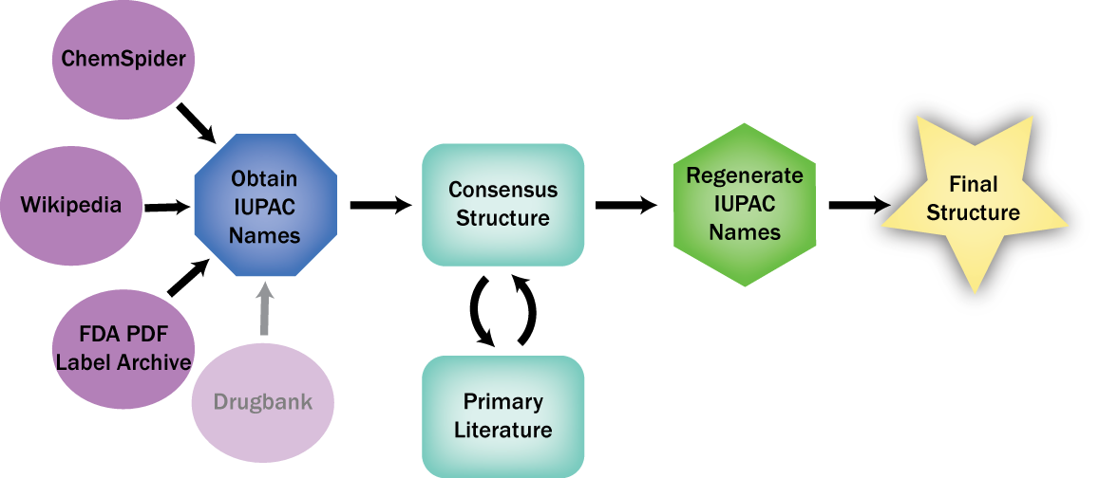
Figure *: The UNC workflow was based entirely on open Internet data repositories and included some manual reentry of structures from PDF sources.

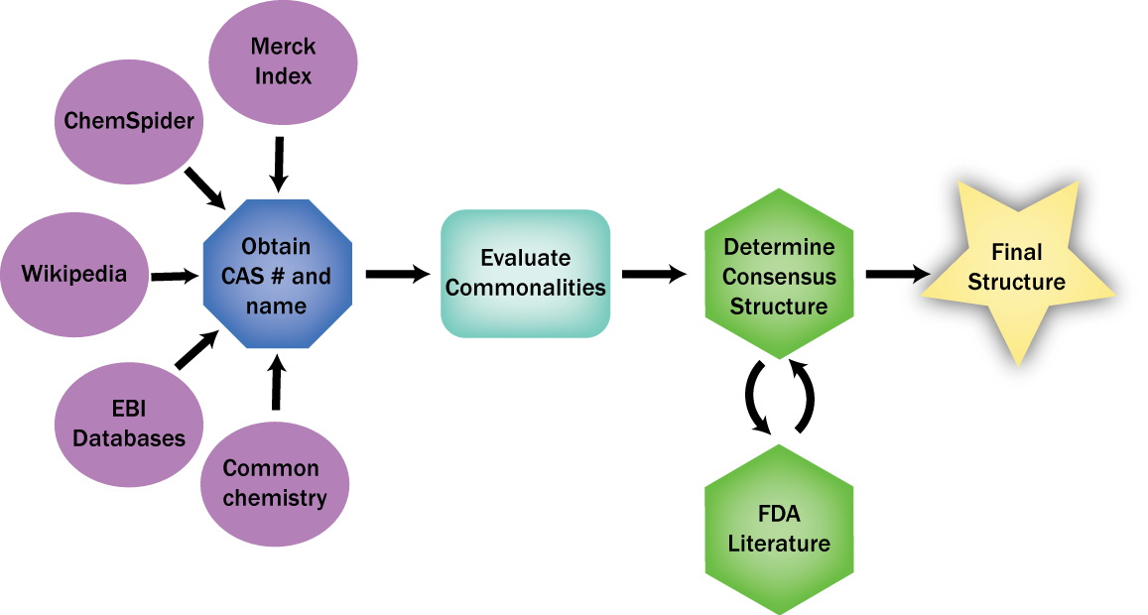
Figure *: The RSC workflow was more iterative in the early stages, and included redistribution-restricted sources in some cases.

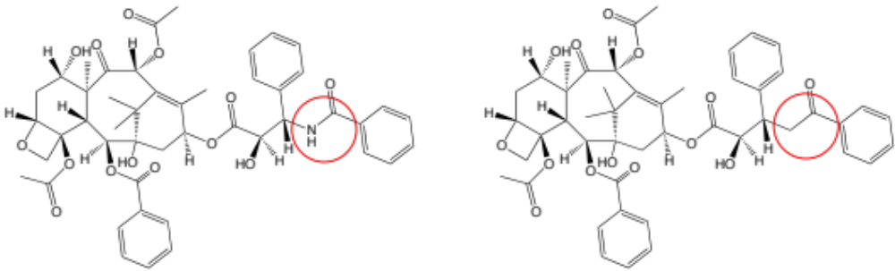

References
Sorel Muresan, Plamen Petrov, Christopher Southan, Magnus Kjellberg, Thierry Kogej, Christian Tyrchan, Peter Varkonyi, Paul Xie-Hongxing, Making every SAR point count: The development of Chemistry Connect for the large-scale integration of structure and bioactivity data to be submitted to Drug Discovery Today
- Williams, A.J. (2008) Internet-based tools for communication and collaboration in chemistry. Drug Discov Today 13 (11-12), 502-506
- Williams, A.J. et al. (2009) Free Online Resources Enabling Crowdsourced Drug Discovery. Drug Discovery World 10, Winter, 33-38
- Gary Wiggins’ Wiki. CHEMBIOGRID, Chemistry Databases on the Web: Alphabetical:http://cheminfo.informatics.indiana.edu/cicc/cis/index.php/Chemistry_Databases_on_the_Web_%28Alphabetical_List%29 and Classified:http://cheminfo.informatics.indiana.edu/cicc/cis/index.php/Chemistry_Databases_on_the_Web_%28Classified_List%29
- Richard AM, Swirsky Gold L, Nicklaus MC: Chemical structure indexing of toxicity data on the Internet: Moving toward a flat world. Current Opinion in Drug Discovery & Development (2006) 9(3): 314-325.
- Zhou Y, Chen K, Yan SF, King FJ, Jiang S, Winzeler EA: Large-Scale Annotation of Small-Molecule Libraries Using Public Databases. J. Chem. Inf. Model. (2007) 47:1386-1394
- Baker M: Open-access chemistry databases evolving slowly but not surely:Nature Reviews, Drug Discovery, (2006) 5:707-708
- Williams, A. J., A perspective of publicly accessible/open-access chemistry databases. Drug discovery today 2008, 13 (11-12), 495-501.
- Williams, A. J., Public chemical compound databases. Current opinion in drug discovery & development 2008, 11 (3), 393-404.
- Williams, A. J.; Ekins, S., A quality alert and call for improved curation of public chemistry databases. Drug Disc Today 2011, 16, 747-750.
- Williams, A. J.; Ekins, S.; Tkachenko, V., Towards a Gold Standard: Regarding Quality in Public Domain Chemistry Databases and Approaches to Improving the Situation. Drug discovery today 2012.
- CTS: Chemical Translation Service. http://uranus.fiehnlab.ucdavis.edu:8080/cts/homePage (accessed October 31st 2011).
- Wohlgemuth, G.; Haldiya, P. K.; Willighagen, E.; Kind, T.; Fiehn, O., The Chemical Translation Service--a web-based tool to improve standardization of metabolomic reports. Bioinformatics 2010, 26 (20), 2647-8.
- Huang, R.; Southall, N.; Wang, Y.; Yasgar, A.; Shinn, P.; Jadhav, A.; Nguyen, D. T.; Austin, C. P., The NCGC Pharmaceutical Collection: A Comprehensive Resource of Clinically Approved Drugs Enabling Repurposing and Chemical Genomics. Sci Transl Med 2011, 3 (80), 80ps16
- Huang, R.; Southall, N.; Wang, Y.; Yasgar, A.; Shinn, P.; Jadhav, A.; Nguyen, D. T.; Austin, C. P., The NCGC Pharmaceutical Collection: A Comprehensive Resource of Clinically Approved Drugs Enabling Repurposing and Chemical Genomics. Sci Transl Med 2011, 3 (80), 80ps16.
- Sansone, S. A.; Rocca-Serra, P.; Field, D.; Maguire, E.; Taylor, C.; Hofmann, O.; Fang, H.; Neumann, S.; Tong, W.; Amaral-Zettler, L.; Begley, K.; Booth, T.; Bougueleret, L.; Burns, G.; Chapman, B.; Clark, T.; Coleman, L. A.; Copeland, J.; Das, S.; de Daruvar, A.; de Matos, P.; Dix, I.; Edmunds, S.; Evelo, C. T.; Forster, M. J.; Gaudet, P.; Gilbert, J.; Goble, C.; Griffin, J. L.; Jacob, D.; Kleinjans, J.; Harland, L.; Haug, K.; Hermjakob, H.; Ho Sui, S. J.; Laederach, A.; Liang, S.; Marshall, S.; McGrath, A.; Merrill, E.; Reilly, D.; Roux, M.; Shamu, C. E.; Shang, C. A.; Steinbeck, C.; Trefethen, A.; Williams-Jones, B.; Wolstencroft, K.; Xenarios, I.; Hide, W., Toward interoperable bioscience data. Nature genetics 2012, 44 (2), 121-6;
- Samwald, M.; Jentzsch, A.; Bouton, C.; Kallesoe, C. S.; Willighagen, E.; Hajagos, J.; Marshall, M. S.; Prud'hommeaux, E.; Hassenzadeh, O.; Pichler, E.; Stephens, S., Linked open drug data for pharmaceutical research and development. Journal of cheminformatics 2011, 3 (1), 19.
- Baker, C. J. O.; Cheung, K.-H., Semantic Web: Revolutionizing Knowledge Discovery in the Life Sciences. Springer: 2010; (b) Antoniou, G.; van Harmelen, F., A Semantic Web Primer. The MIT Press Cambridge: Massachusetts London, England, 2004; (c) Neumann, E.; Prusak, L., Knowledge networks in the age of the Semantic Web. Briefings in bioinformatics 2007, 8 (3), 141-9.

Fourches, D. et al. (2010) Trust, but verify: on the importance of chemical structure curation in cheminformatics and QSAR modeling research. J Chem Inf Model 50 (7), 1189-1204

